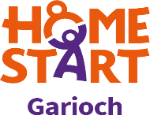

HOME-START GARIOCH

VOLUNTEER PROFILE

A Home-Start volunteer should normally have an understanding of the problems and pleasures of family life.

Volunteers should:

- Have a positive attitude to working with of any gender, family status or sexual identity, or who are from any ethnic origin, culture or religion, or who may have a disability

- Demonstrate a sensitive and caring attitude towards others

- Have a non-judgemental attitude

- Be clear about confidentiality and when a confidence remains so, but be able to decide when disclosure of a confidence is essential to the well-being of the child

- Be reliable and understand the importance of reliability to the family

- Have good communication skills including an ability to listen

- Understand the need for support

- Have a warm and open personality and a sense of humour

- Have time and enthusiasm for Home-Start

- Be able to work as a member of a team

- Be prepared to keep records as requested by the scheme.

